IDE:- (Integrated Development Environment)

* Compiler
* Interpreter
* Debug
* Test
* Documentation
* Build

Java based IDE:-

Elicpse

Intelij

Netbeans

JCreator

Java application – console – java perspective

Java web application – java EE

Fahrenhiet to Centigrade

C/5 = (F-32)/9

Naming convention of java programming:-

======================================

class name - each word starting letter must be in capital

reserved keywords - for, while, do, class, public, switch, static

\* all letters in lowercase

variable name

- if variable is a single word

\* all letters must be in lowercase

- if variable has more than one word

\* First word all letters must be in lowercase

\* second word onwards each word starting letter

must be in capital

- if the variable is an constant variable

\* all words letters in capital

method name

- if method name is a single word

\* all letters must be in lowercase followed by ()

- if method name has more than one word

\* First word all letters must be in lowercase

\* second word onwards each word starting letter

must be in capital follwed by ()

interface name - each word starting letter must be in capital

packages name- all letters in must be in smaller letters

Variable:-

Variable is an identity to the memory location

variable:-

It is an identity to the memory location

Types of variable:-

1. instance variable

A variable declared inside the class and outside of any method

2. static variable

A variable declared inside the class and outside of any method with the static keyword

3. local variable

A variable declared inside the class and inside any of the method or inside the block

Scope-> how far that variable can be accessable

Lifetime-> That variable how long it is going to be there in the memory

Eg:

public class Trainee {

int traineeId; // primitive instance variable

String traineeName;//reference instance variable

static String location;//static reference variable

static int traineeSalary; //static primitive variable

public static void main(String[] args) {

int total; // local variable

{

int a; //local variable

}

}

}

Customerid =5657 -> byte,short,int,long

Name=”rajesh” -> String

Roi = 5.6f;-> float, double

Gender =’m’ -> char

MARRITALSTATUS = true or false-> boolean

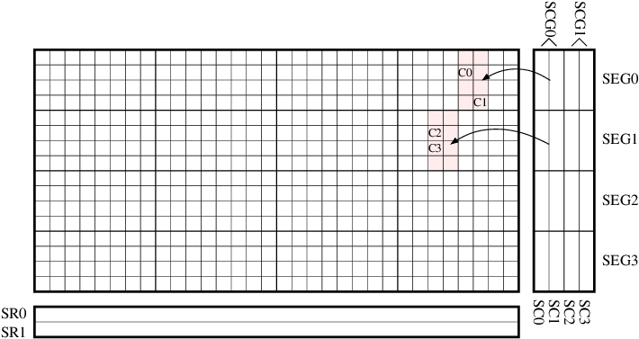

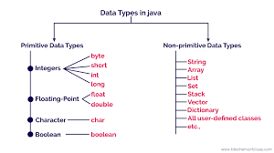

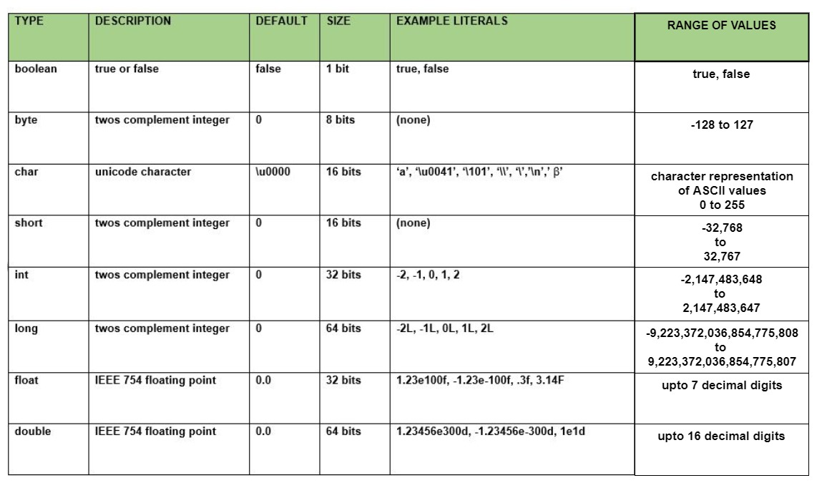

Accessspecifier returntype methodname(){

Statements;

Statements;

}

Method without an argument without return type

public void emiEstimation() {

}

Method with an arguement without return type

public void emiEstimation(arg) {

}

Method without an argument with return type

public datatype emiEstimation() {

return value;

}

Method withan arguement without return type

public datatype emiEstimation(arg) {

return value;

}

Java:-

Is an object oriented Language

Class and objects

Objects-> real-world existing things are object

Properties

Behavior

Chair -> objects

Properties

Price, type, cushion, capacity,color,

Behavior

Sit(), rolling(), adjustHeight();

Trainee – object

Id, name, salary, technology,email,phone

Learning(), assignment(),task(),break()

Classname referencevariablename=new Classname();

Scanner s=new Scanner();

Trainee t=new Trainee();

Packages:

* To organize related java classes or grouping the related classes
* Class name collision
* Visibility

Banking

Account.java

Customer.java

Transaction.java

Deposit.java

Withrawl.java

Creditacred.java

Debitcard.java

Cheque.java

Statement.java

Loan.java

CarLoan.java

HomeLoan.java

Access Modifier:-

* Visibility – how far class and class members can be access
  + - Before the class
    - Before the variable
    - Before the methods
    - Before the constructor

Public

Private -> can be accessible with in the class

Default

protected